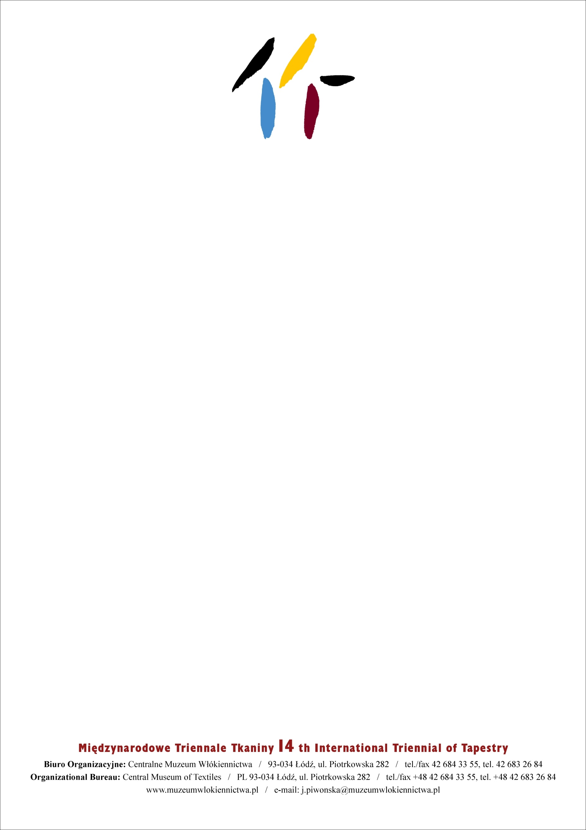

# DONATION AGREEMENT

Donation agreement concluded on (date)__________________________________________  
between Mr./Mrs.(name, surname)_______________________________________________  
place of residence_(address) ____________________________________________________  
further called the DONATOR  
and the Central Museum of Textiles in Łódź, ul. Piotrkowska 282, NIP (Taxpayer Identification Number) 729-11-25-803, represented by the Director Marcin Oko and Chief Accountant Dorota Krakowiak further called the RECIPIENT.

§1

The Donator certifies that he/she is the author and owner of the work entitled  
___________________________________________________________________________  
further called the Work of Art, value _____________________________________________  
which is donated to the Recipient, i.e. the Central Museum of Textiles in Łódź, with no conditions or forms of payment with transfer property copyright of the Work of Art, and

the Recipient accepts it.

§2

The hereby Agreement was drawn up in two identical copies.

Donator Recipient